Microprocessor

* It is brain of computer
* It is a single chip which is capable of processing data.
* It controls all the components in computer .eg monitor,keyboard,usb etc
* It fetch,decode and execute the instruction

# Defination

• A microprocessor is a programmable electronic chips that has computing and decision making capacity similar to central processing unit of computer

# Bus organization of 8085

• Bus is a group of conducting wires which carries information all the peripheral are connected to microprocessor through Bus.

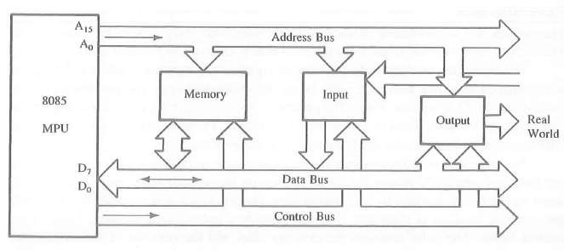

# Address Bus

* Is a group of conducting wires which carries address/particular location only.
* It is unidirectional only ie data flows from microprocessor to memory or from microprocessor to i/o device.
* Length of address bus is 16 bit(0000H to FFFFH)
* It can transfer maxmimum 16bit address which means it can address 65536 different memory location.

# Data Bus

* Conducting wire carries data only.
* Bidirectional because data flow in both direction from microprocessor to memory or i/o device.
* Length of data bus of 8085 is 8bit (00H to FFH)
* The width of data bus is directly related to the largest number that bus can carry such as 8 bit bus can represent 2^8 (0-255)

# Control bus

* Use to generate timing and control signal to control all associated peripherals.
* Uses control signal to process data that is what to do with selected memory location. Some control signal are
* Memory read
* Memory write
* i/o read
* i/o write
* Opcode fetch

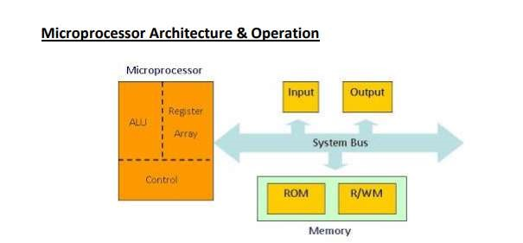

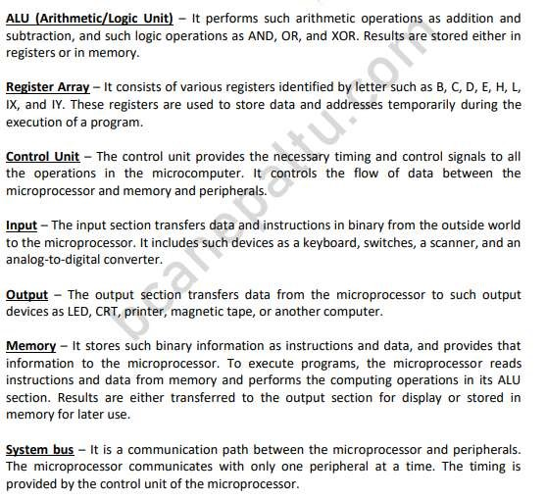

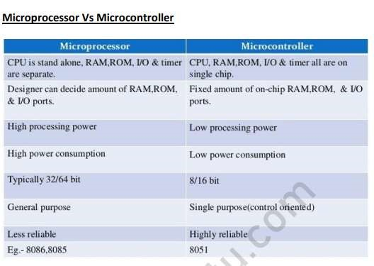

# Processor overview

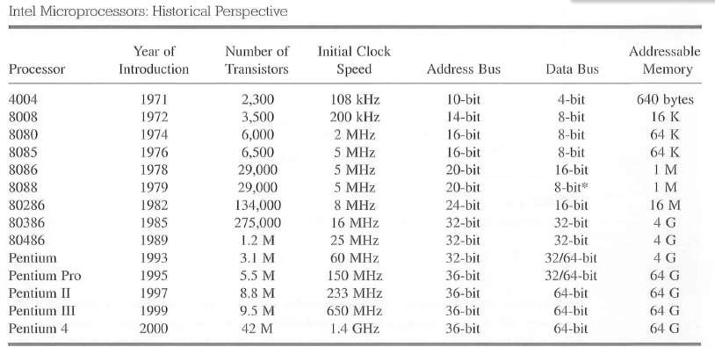

# 8085 instruction set

Classified into five functional categories:

* Data transfer(Copy) operation
* Arithmetic operation
* Logical operation
* Branching operation
* Machine control operation

# Data transfer(copy) operation

* Copies data from a location called source to another location called Destination without modifying the content of source.
* The various types of data transfer are:
* Between register
* Specific data byte to register
* Between memory location and a register
* Between i/o device and accumulator

# Arithmetic Operation

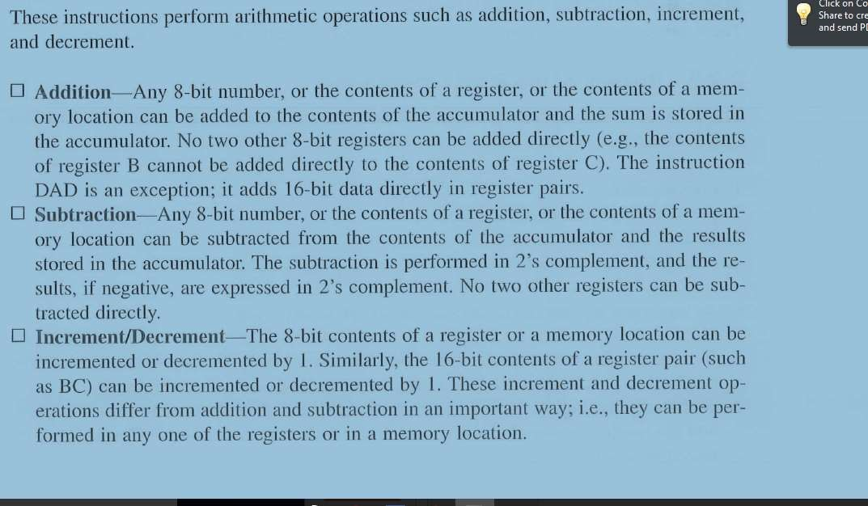

# Logical Operation

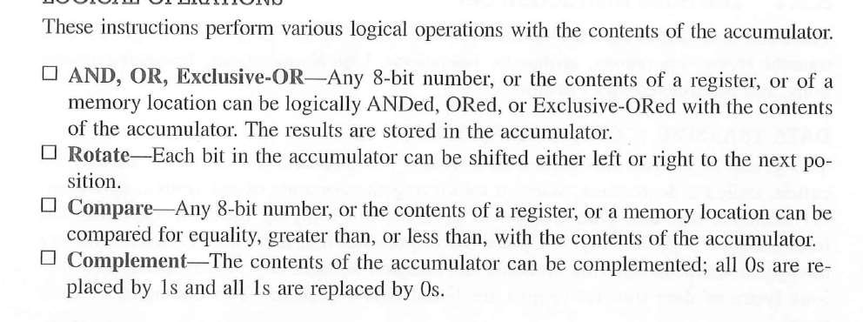

# Branching operation

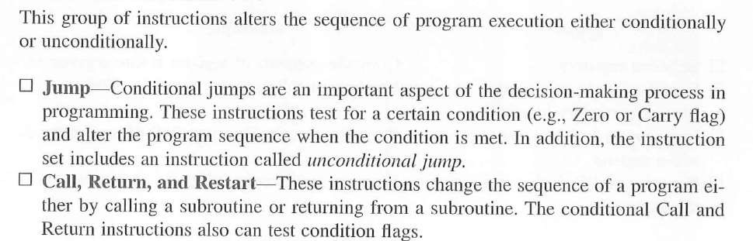

Machine control operation

• Control machine function such as Halt,Interrupt.

# Instruction

* Is a command to the microprocessor to perform a given task on specified data.
* Each instruction has two parts

One is the task to be performed called operational code(op-code) Data to be operated on called operand

May include 8 or 16 bite data ,an internal register ,a memory location.

# Instruction Word Size

* 1-Byte instruction • 2-Byte instruction
* 3-Byte instruction

# 1 byte instruction

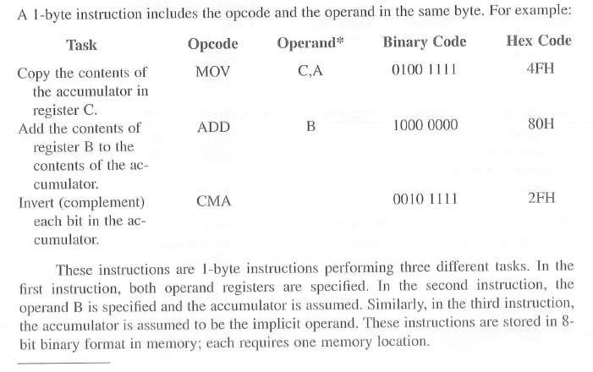

# 2-byte instruction

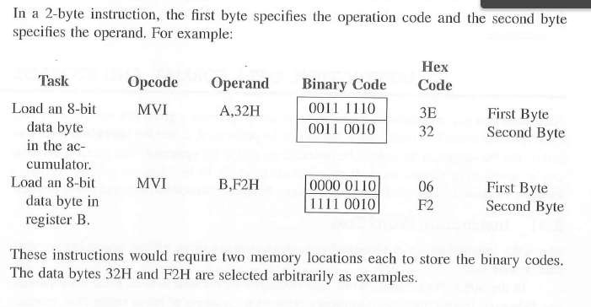

# 3-byte instruction

